Project Report: Comprehensive Data Governance Pipeline with Azure Purview

1. Introduction
Data has become one of the most valuable organizational assets, and managing it effectively is critical for compliance, analytics, security, and operational efficiency. As enterprises increasingly adopt cloud-based data lakes, challenges arise in ensuring data governance, transparency, and regulatory adherence. Traditional manual governance approaches do not scale to the size, diversity, and velocity of modern data systems.
This project focuses on designing and implementing a Comprehensive Data Governance Pipeline using Azure Purview, Azure Data Lake Storage Gen2, and Azure Synapse Analytics. The aim is to automate data discovery, classification, lineage tracking, and cataloging while ensuring enterprise-grade security and compliance. The solution provides organizations with full visibility across their data estate and supports advanced analytics with integrated governance.

2. Problem Statement
Organizations commonly face challenges when managing distributed and large-scale data lakes. Key issues include:
- Lack of automated metadata management and data cataloging
- Difficulty in identifying sensitive data for compliance (GDPR, HIPAA, etc.)
- Inability to track data lineage across ETL pipelines
- Manual governance workflows leading to errors and inconsistencies
- Poor visibility into data quality and ownership
- Absence of centralized governance across hybrid and multi-cloud platforms
These challenges lead to compliance risks, operational inefficiencies, and an inability to derive accurate insights from data. A robust and automated data governance solution is essential to address these issues.

3. Objectives
The primary objectives of this project are:
- To design an end-to-end automated data governance pipeline.
- To implement Azure Purview for metadata cataloging, automated classification, and lineage tracking.
- To integrate Azure Data Lake Storage Gen2 as the core storage layer.
- To connect Azure Synapse Analytics for data processing and lineage generation.
- To demonstrate governance workflows using sample datasets.
- To ensure the platform supports compliance, transparency, and data security.

4. Proposed System Architecture
The architecture of the data governance pipeline is designed to ensure seamless integration between data storage, governance, analytics, and compliance monitoring layers.

Architecture Diagram
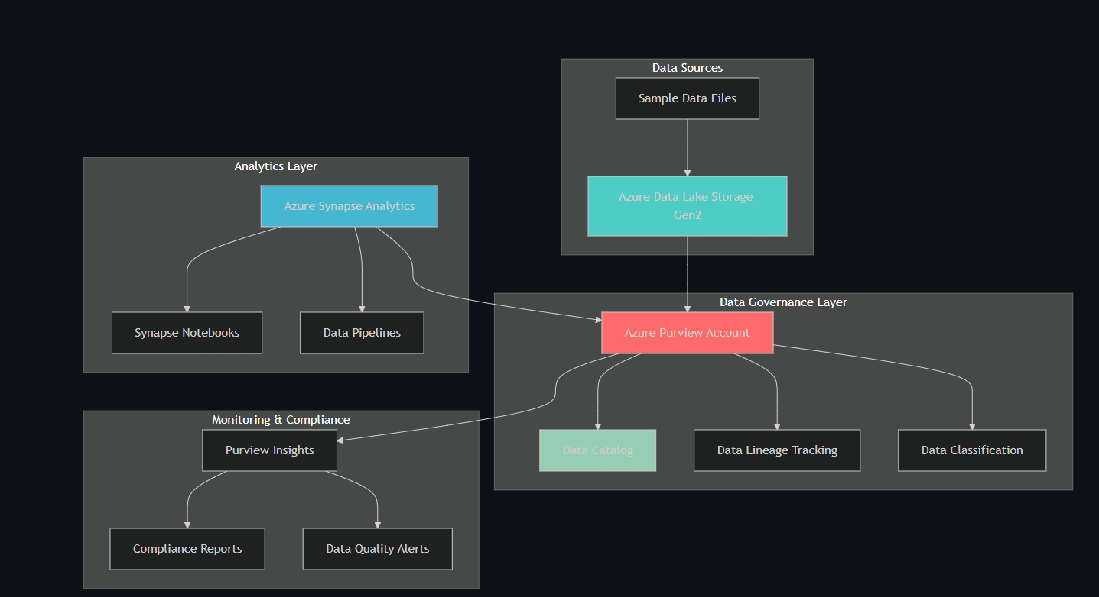

4.1 Data Flow Diagram

Data Flow Diagram 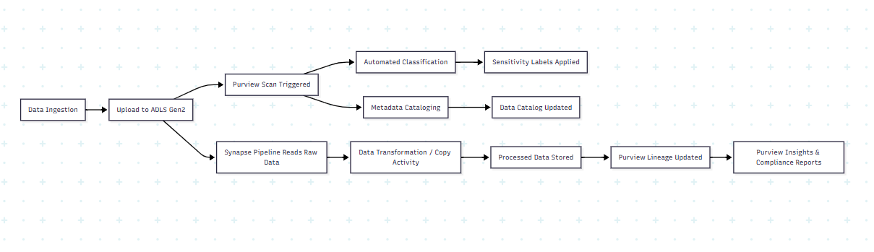

Data Flow Description
- Ingestion – Data enters Azure Data Lake Storage.
- Purview Scan – Automatic metadata and classification scan begins.
- Classification & Cataloging – Sensitive data is tagged and catalog updated.
- Processing – Synapse pipelines read and process data.
- Output Storage – Processed data written back to ADLS.
- Lineage Tracking – Purview maps transformation flow.
- Insights & Compliance – Reports generated based on lineage and classifications.
- The architecture consists of four major layers:

1. Data Sources Layer
- Azure Data Lake Storage Gen2 acts as the central enterprise data lake.
- Raw, processed, and sensitive datasets are stored in separate containers.

2. Data Governance Layer
- Azure Purview automatically discovers datasets, classifies sensitive fields, and builds a unified metadata catalog.
- Lineage tracking provides full visibility of data transformations.

3. Analytics Layer
- Azure Synapse Analytics processes datasets and triggers lineage events.
- Pipelines move data between zones to support analytics workflows.

4. Monitoring & Compliance Layer
- Purview Insights generates compliance, classification, and data quality reports.
- Alerts simplify audit readiness and governance monitoring.

5. System Implementation Details
The implementation follows a structured approach using Azure CLI, Bash scripting, and manual Purview configuration.

Step 1: Environment Initialization
- Creation of a dedicated Resource Group
- Registration of required Azure providers (Purview, Storage, Synapse)
- Definition of environment variables for repeatable deployments

Step 2: Storage Layer Setup
- Creation of an Azure Data Lake Storage Gen2 account
- Enabling hierarchical namespace for directory-level analytics
- Creation of domain-specific containers:
  - raw-data
  - processed-data
  - sensitive-data
- Uploading sample CSV files to demonstrate classification and lineage

Step 3: Purview Account Deployment
- Provisioning of Azure Purview and its managed resource group
- Retrieving catalog endpoint for dashboard and metadata access
- Assigning RBAC roles:
  - Purview Managed Identity → Storage Blob Data Reader
  - User Identity → Purview Data Curator

Step 4: Synapse Integration
- Creation of Synapse Workspace connected to ADLS
- Configuration of firewall rules for secure access
- Deployment of governance test pipeline to generate lineage

Step 5: Automated Classification Rules
Custom classification rules created using JSON templates: - Email Address (Regex-based) - Phone Number (Regex-based) - Physical Address (Keyword-based)
Along with sensitivity labels: - Public - Internal - Confidential - Restricted
Purview automatically applies these labels during scanning.

Step 6: Pipeline Creation & Lineage Testing
- A Synapse “Copy” pipeline moves files from raw-data → processed-data
- Purview captures lineage:
  - Source dataset
  - Transformation activity
  - Output dataset
- This enables full traceability of data flow

6. Validation and Testing
The system was validated across the following checkpoints:

Purview Account Verification
- Provisioning state validated via CLI
- Verified accessible catalog endpoint

Data Lake Verification
- All containers listed successfully
- Uploaded sample files detected by Purview scans

Synapse Integration Testing
- Workspace successfully connected to storage
- Pipelines executed generating lineage metadata

Role Assignment Verification
- Purview managed identity successfully received Storage Reader permissions

7. Results and Findings
The project successfully demonstrates a functioning automated governance pipeline. Key achievements include:

1. Complete Metadata Visibility
All datasets were discovered, cataloged, and grouped logically using Purview.

2. Automated Sensitivity Classification
- Email and phone fields flagged as High and Medium sensitivity
- Automatic tagging supports compliance workflows

3. End-to-End Lineage Tracking
Purview generated detailed lineage graphs: - Ingestion → Processing → Output datasets - Captured ETL transformations from Synapse pipeline

4. Compliance Insights Generation
Purview Insights dashboard produced compliance reports for: - Scan completeness - Classification coverage - Asset distribution

5. Scalable and Modular Design
The system supports extension to: - Multi-cloud data governance (AWS S3 / GCP) - Additional classification rules - Data quality rule integration

8. Conclusion
This project successfully implements a scalable and automated Data Governance Pipeline using Azure Purview, ADLS Gen2, and Synapse Analytics. The solution addresses major governance challenges by providing: - Centralized metadata catalog - Automated discovery and classification - End-to-end lineage visibility - Compliance reporting and risk reduction - Integration with data analytics workflows
By adopting this pipeline, enterprises can significantly enhance their governance maturity, reduce regulatory risks, enable self-service analytics, and improve overall data quality.

9. Future Scope
The solution can be expanded with the following advanced capabilities:

1. Multi-Cloud Governance
Extend metadata scanning to AWS S3, Google Cloud Storage, and on-prem systems.

2. Data Quality Monitoring
Integrate Azure Data Factory rules and Azure Monitor alerts.

3. Privacy Impact Assessment Automation
Trigger Logic Apps workflows based on classification outcomes.

4. Power BI Compliance Dashboards
Visualize Purview metadata for stakeholders.

5. Advanced Lineage Tracking
Track Databricks notebooks, Data Factory pipelines, and third-party ETL tools.

10. References
- Microsoft Purview Documentation
- Azure Synapse Analytics Documentation
- Azure Storage & Governance Best Practices

